# 1.Learn the theory and implementation of paper “A Neural Algorithm of Artistic Style”, Leon A.Gatys

Progress 2

The objective of this part is to improve a current method based on Convolutional Neural Network. I learned the theory and method of how to implement it, and tend to test it with our dataset.

1. Learn the theory and implementation

of paper “*A Neural Algorithm of Artistic Style”, Leon A.Gatys.*

(Zhiyuan Tao)

Why CNN Can Be Applied in Neural Style Transfer

In Convolutional Neural Network (CNN), each layer of feature map extract different features of the input image. Applying this property, images could be directly visualized only from the one layer to show these features individually. This is because a feature map nearer the input layer experience less convolution and pooling, thus has more texture information; a feature map nearer the output layer are extracted with more textures in detail, thus it contains the content information mainly.

Algorithm Overview

Input style image $\overset{⃑}{α}$ and content image $\overset{⃑}{p}$, then a series of feature maps are obtained for each of them. Update object image $\overset{⃑}{x}$ with gradient descent with $Gradient \frac{∂L_{total}}{∂\overset{⃑}{x}}$.

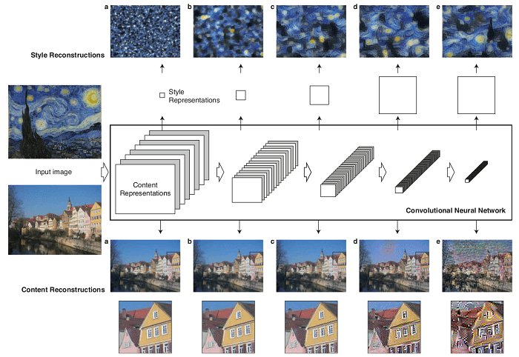

Fig. Image representations and reconstructions in a convolution neural network

(1) Representation of Content

Square-error Loss function

$$L_{content}(\overset{⃑}{p},\overset{⃑}{x},l)=\frac{1}{2}\sum_{i,j}{{\left(F_{i,j}^{l}-P_{i,j}^{l}\right)}^{2}}$$

where

$l : number of layers$

$F : a feature map of \overset{⃑}{x}$

$P : a feature map of \overset{⃑}{p}$

$i :the number i feature map in a layer$

$j :the position of a pixel$

Using standard error back-propagation to compute the gradient:

$$\frac{∂L_{content}}{∂F_{i,j}^{l}}=\left\{\begin{aligned}{ \left(F^{l}-P^{l}\right)}_{ij} if F_{i,j}^{l}>0 \\ 0 if F_{i,j}^{l}<0\end{aligned}\right.$$

(2) Representation of Style

Texture feature is not corresponded with the location in an image, so disturb the location information to maintain this property with Gram matrix.

$$G_{i,j}^{l}=\sum_{k}{F_{i,k}^{l}F_{j,k}^{l}}$$

Total Loss Function:

$$L_{style}=\sum_{k}{w_{l}E_{l}}$$

$$E_{l} is the square error of$$

$$Gram matrix A{}_{l} whose the feature map S_{l} of \overset{⃑}{α} and$$

$$Gram matrix G{}_{l} whose the feature map F_{l} of \overset{⃑}{x}$$

Gradient:

$$\frac{∂E_{l}}{∂F_{i,j}^{l}}=\left\{\begin{aligned}{ \frac{1}{N_{l}^{2}M_{l}^{2}}\left({\left(F^{l}\right)}^{T}(G^{l}-P^{l}\right))}_{ji} if F_{i,j}^{l}>0 \\ 0 if F_{i,j}^{l}<0\end{aligned}\right.$$

Where

$$N_{l} is the number of feature maps,$$

$$M_{l} is the number of pixel numbers in each feature map$$

(3) Style Transfer

Minimization the Loss Function

$$L_{total}=αL_{constent}\left(\overset{⃑}{p},\overset{⃑}{x}\right)+βL_{style}\left(\overset{⃑}{a},\overset{⃑}{x}\right)$$

Hyper-parameter $α$ denotes content weight, and $β$ denotes total variation weight. They could be selected to decide the output image is more similar with content of $\overset{⃑}{p}$ or with style of $\overset{⃑}{α}$.

1. Implement CNN-based method

with DTD dataset and find the ideas to improve

The dataset has 47 categories and 120 images in each category, and it is already split for train, validation and test. The categories contain lacelike, wrinkled, crystalline, braided, fibrous and so on. It’s very abundant for us to test whether the algorithm could be comprehensive enough to adapt with different kind of textures.

The dataset provides key attribute (main category) and a list of joint attributes. Thus, it’s free for us to choose if a single texture should be test or multiple textures should be test for each trial.

The main task is to choose a texture picture as one of the inputs and try to transfer the style of it to another content picture.

The evaluation could consist of two part. One is to observe with our eyes and decide subjectively if the style is transferred successfully. Another one is applying the loss function.

Image from:

https://towardsdatascience.com/neural-style-transfer-on-real-time-video-with-full-implementable-code-ac2dbc0e9822

Reference:

Gatys, Leon A., Alexander S. Ecker, and Matthias Bethge. "A neural algorithm of artistic style." *arXiv preprint arXiv:1508.06576* (2015).

# 2.Python grammar, class, module, function …

# 3. deep learning tutorial

# 4.improve based on some code with pytorch/tensorflow/keras

Pytorch

Need to improve:

1.Image resize before or after tensor ✔️

Points

2. generate texture, only need to use left and middle sides.

5. Experiment

Choose textures, run multiple times, get an average loss

Loss curve

Extract “loss style” function to evaluate 3 models (texture, CNN, GAN)